
Integrity, Inclusion, Education, Excellence
Fall Fiesta “Sprint Spectacular” ABC Meet
Hosted by Rockford Riptide
Sunday, November 13th, 2016

Sanction - This meet is sanctioned by Michigan Swimming, Inc. (MS), as a timed final meet on behalf of USA Swimming (USA-S), Sanction Number MI1617028. In granting this sanction it is understood and agreed that USA Swimming shall be free from any liabilities or claims for damages arising by reason of injuries to anyone during the conduct of the event. MS rules, safety, and warm up procedures will govern the meet as is fully set forth in these meet rules.
Location - Rockford High School Pool, 4100 Kroes Rd, Rockford, MI 49341
Times – Sunday Am: Warmup 8:00 am, Events Start 9 am
Sunday PM: Warmup to begin immediately after the am Session, but not before 12:30 PM. The event start time will be approximately 1 hour after the start of warmups.
Motels – Comfort Suites Hotel, 350 Dodge Street NW, Comstock Park, MI 49321 (616) 785-7899
Facilities – The Rockford High School Pool , is an 8 lane pool with a supervised warm-up and warm down area available. Depth at start is 14” and 5’5” at turn. Permanent starting blocks and non-turbulent lane markers will be used. A Colorado timing system with an 8 lane display will be used. There is ample balcony seating for spectators. Lockers are available (provide your own lock). Public phones will not be available. The competition course has not been certified in accordance with 104.2.2C (4)
Eligibility – The Fall Fiesta Meet is for those swimmers of all ages and abilities. All swimmers must be currently registered with United States of America Swimming (USA-S). A swimmer's age on November 13, 2016 will determine his/her eligibility for a particular age group.
Deck Registration - Unregistered swimmers must register on deck at this meet by turning in the athlete registration form and payment to the Meet Referee. The cost of registering on deck is double the normal fee ($148.00 per swimmer for 2016-17 registration).
Meet Format – The Fall Fiesta has a timed finals ABC format.
Entry Limits - Entries will be accepted on a first come first serve basis by date of email for electronic entries and date of receipt by the Administrative Official for hard copy entries until the Michigan Swimming Four (4) hour per session maximum time limit is met. As set forth in entry procedures below, (A) a hard copy of your club’s entry summary sheet, (B) a hard copy of your club’s signed release/waiver agreement (C) your club’s certification of entered athletes and (D) your club’s entry and entry fees must be received by the Entry Chair in a timely fashion prior to the start of the meet, or your swimmers will not be allowed to swim in the meet. Entries received after the four (4) hour per session time limit has been met will be returned even if received before the entry deadline.
Swimmers Without A Coach - Any swimmer entered in the meet, unaccompanied by a USA-S member coach, must be certified by a USA-S member coach as being proficient in performing a racing start or must start each race from within the water. It is the responsibility of the swimmer or the swimmer’s legal guardian to ensure compliance with this requirement.
Individual Entry Limits – Swimmers may enter into a maximum of four (4) individual events and one relay event per day. The Maximum entry limit each day would be inclusive of time trials and deck entries.
Electronic Entries - $5 per individual event and $12 for relays. Please include a $1.00 Michigan Swimming surcharge for each swimmer entered. Make checks payable to: Rockford Riptide.
Paper Entries - MS rules regarding non-electronic entries apply. $6 per individual event and $7 for relays. There is a $1.00 additional charge per individual event and $1.00 per relay event paid if the entry is not submitted in Hy-Tek format. The Michigan Swimming $1.00 general surcharge for each swimmer also applies to paper entries. Paper entries may be submitted to the Administrative Official on a spreadsheet of your choice however the paper entry must be logically formatted and must contain all pertinent information to allow the Administrative Official to easily enter the swimmer(s) in the correct events with correct seed times.
Entry Procedures - Entries may be submitted to the Administrative Official as of Monday, October 21st at 9 pm. The Administrative Official must receive all entries no later than Tuesday, November 1. Entries must include correct swimmer name (as registered with USA/MS Swimming), age and USA number. You can import the order of events and event numbers from the Michigan Swimming website (http://www.miswim.org/). All individual entries should be submitted via electronic mail to the Administrative Official at coachmcutler@riptide.org. All entries will be processed in order by email date code or mail date code. Any entries submitted will be considered provisional until such time as the Administrative Official has received a hard copy of: (a) your club's entries (Team Manager Meet Entries Report), (b) a hard copy of your club's signed release/waiver agreement (c) your clubs signed certification of entered athletes and (d) your club's entry fees. This must be received in a timely fashion prior to the start of the meet or your swimmers will not be allowed to swim in the meet. The complete Fall Fiesta entry packet with entry forms is available on the Michigan Swimming Website at http://www.miswim.org/
Refunds - Once a team or individual entry has been received and processed by the Administrative Official there are no refunds in full or in part unless the “over qualification exception” applies (see MS Rules).

Entries - Your club's Entry, Entry Summary Sheet, Release/Waiver, Certification of Entered Athletes and Check should be sent via U.S. mail or nationally recognized overnight courier to:
Mike Cutler, c/o Rockford Riptide
PO Box 382, Rockford, MI 49341
CoachMCutler@Riptide.org

Check In - Check in will be required. If required, it will be available 30 minutes prior to the start of warm-up for each session. If mandatory check in is used, it will be required by the time set forth in this meet announcement. Failure to check in, if required, it will cause the swimmer to be scratched from all events in that session. Check in will close 15 minutes after the start of warm up for each session. Check in sheets will be posted at the entrance to the pool area, prior to entering the locker rooms.
Scratch Rules –Prior to check in close a swimmer may scratch events at the Clerk of Course. After check in closes, you must see the Meet Referee to scratch an event.
Marshaling – Self-Marshaling will be used for all swimmers. Heat sheets will be posted around the pool after check-in closes and seeding is complete.
Seeding – will be done after check in closes. Swimmers who fail to check in for an event, will be scratched from that event. All events are timed finals and will be seeded slowest to fastest.
Deck Entries/Time Trials – Deck entries will be accepted prior to seeding of the meet if the Michigan Swimming four (4) hour per session maximum time limit is not met. Time trials may be allowed if the timeline allows and the Meet Refere and Meet Director approve it. Deck Entry and Time Trial Entries are $7 for individual events and $15 for relays. Deck entry and time trial swimmers are subject to the Michigan Swimming $1.00 general surcharge if they are not already entered in the meet. For deck entries, registration status must be proven by providing a current USA Swimming membership card or a current print out of an athlete roster from the Club Portal, the Club Portal is located on the USA Swimming website. The athlete may also enter by showing their membership from USA Swimming’s DECK PASS on a smart phone. Name, athlete ID and club affiliation should then be added to your database just as it appears on the card or list or the swimmer may compete unattached (UN) if they request to do so.
Meet Programs/Admissions – Admission is $5 per person per day. Children 10 and under, with an adult, are free Heat sheets will be available for $2..
Scoring - Scoring will be kept for all sprint events. Sprint events are defined as 25’s and 50’s of all strokes as well as 100IM, 100 Freestyle and all relays. The points for the top three swimmers from each team in the sprint events will count toward the team total. Standard scoring will be used.
Awards – Medals will be awarded for 1st thru 3rd place and ribbons 4th thru 12th place. The age groups will be 8 and under, 9-10, and 11-12, with “A”, “B”, & “C” for individual events. There will not be award for Open events. 1st thru 3rd medals will also be awarded to 12 & Under relays. All Awards will be available for pick up by the coaches following the PM session on Sunday.
Results - Complete Official meet results will be posted on the Michigan Swimming Website at http://www.miswim.org/ . Unofficial results will also be available on flash drive (HY-TEK Team Manager result file) upon request. Teams must provide their own flash drive.
Concessions - Food and beverages will be available in concessions area immediately outside the pool balcony. No food or beverage will be allowed on the deck of the pool, in the locker rooms or in the spectator areas. A hospitality area will be available for coaches and officials.
Lost and Found - Articles may be turned in/picked up at the pool office. Articles not picked up by the end of the meet will be retained by the Meet Director or a representative for at least 14 days (any longer period shall be in the sole discretion of the Meet Director).
Swimming Safety - Michigan Swimming warm up rules will be followed. To protect all swimmers during warm-ups, swimmers are required to enter the pool feet first at all times except when sprint lanes have been designated. No jumping or diving. The same rules will apply with respect to the warm-down pool and diving well. Penalties for violating these rules will be in the sole discretion of the Meet Referee which may include ejection from the meet.
Deck Personnel/Locker Rooms/Credentialing - Only registered and current coaches, athletes, officials and meet personnel are allowed on the deck or in locker rooms. Access to the pool deck may only be granted to any other individual in the event of emergency through approval by the Meet Director or the Meet Referee. The General Chair of MS, Program Operations Vice-Chair of MS, Officials Chairs of MS, and the Michigan Swimming Office staff are authorized deck personnel at all MS meets. Personal assistants/helpers of athletes with a disability shall be permitted when requested by an athlete with a disability or a coach of an athlete with a disability.
Lists of registered coaches, certified officials and meet personnel will be placed outside the outside the entrance to the pool deck from the staircase closest to the football stadium. Meet personnel will check the list of approved individuals and issue a credential to be displayed at all times during the meet. This credential will include the host team logo (Riptide) , name (Fall Fiesta) as well as the function of the individual being granted access to the pool deck (Coach, Official, Timer, or Meet Personnel). In order to obtain a credential, Coaches and Officials must be current in all certifications through the final date of the meet. Meet personnel must return the credential at the conclusion of working each day and be reissued a credential daily.
All access points to the pool deck and locker rooms will either be secured or staffed by a meet worker checking credentials throughout the duration of the meet.
Swimmers with Disabilities - All swimmers are encouraged to participate. If any of your swimmers have special needs or requests please indicate them on the entry form and with the Clerk of Course and/or the Meet Referee during warm ups.
General Info - Any errors or omissions in the program will be documented and signed by the Meet Referee and available for review at the Clerk of Course for Coaches review. Information will also be covered at the Coaches’ Meeting.
First Aid - Supplies will be kept in the lifeguard station outside of the pool office.
Facility Items –
(A) No smoking is allowed in the building or on the grounds of Rockford Public Schools.
(B) Pursuant to applicable Michigan law, no glass will be allowed on the deck of the pool or in the locker rooms.
(C) No bare feet allowed outside of the pool area. Swimmers need to have shoes to go into the hallway to awards or concessions.
(D) An Emergency Action Plan has been submitted by the Host Club to the Safety Chair and the Program Operations Chair of Michigan Swimming prior to sanction of this meet and is available for review and inspection at the Pool office.
(E) To comply with USA Swimming privacy and security policy, the use of audio or visual recording devices, including a cell phone, is not permitted in changing areas, rest rooms or locker rooms.
(F) Deck changing, in whole or in part, into or out of a swimsuit when wearing just one
suit in an area other than a permanent or temporary locker room, bathroom,
changing room or other space designated for changing purposes is prohibited.

.
Meet Director – Marjorie Schuchardt (a USA Swimming member)
Meet Referee – Steve Weeks, steve.weeks@evoqua.com
Safety Marshal – Terri Eudy
Administrative Official – Mike Cutler, coachmcutler@riptide.org, 616-206-8950

Fall Fiesta List of Events
Sunday AM, November 13th
Girls Boys
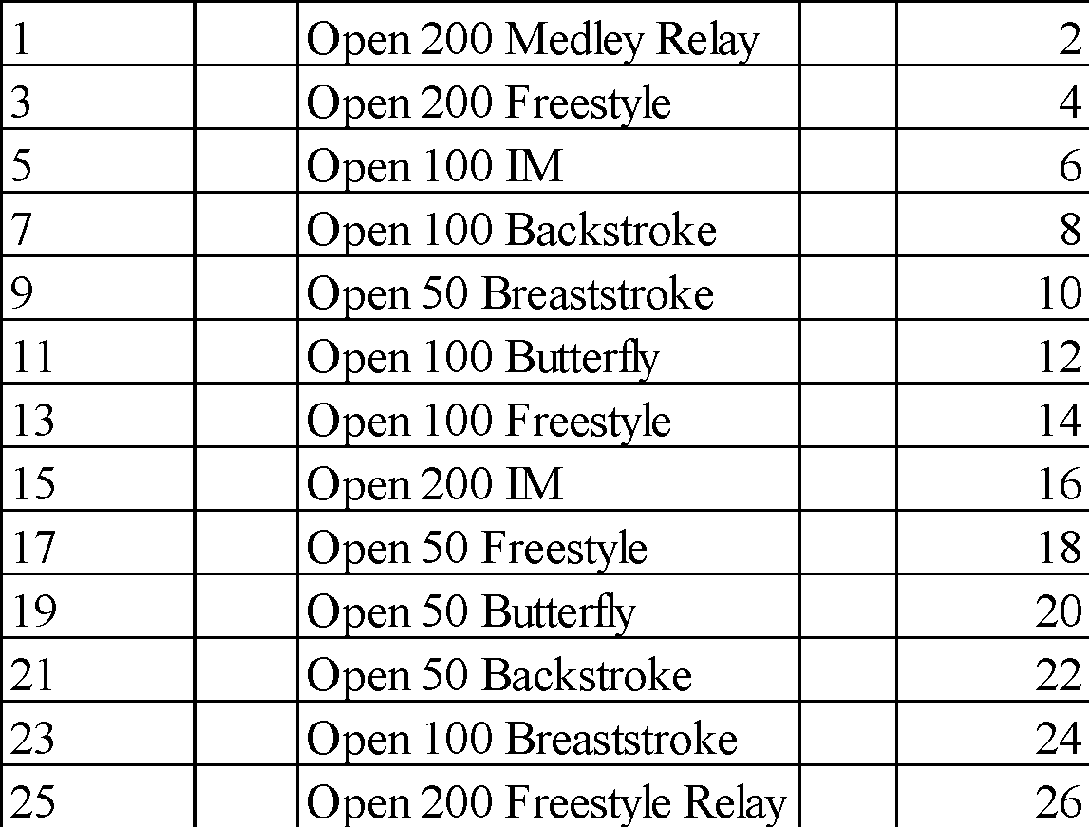
Sunday PM, November 13th
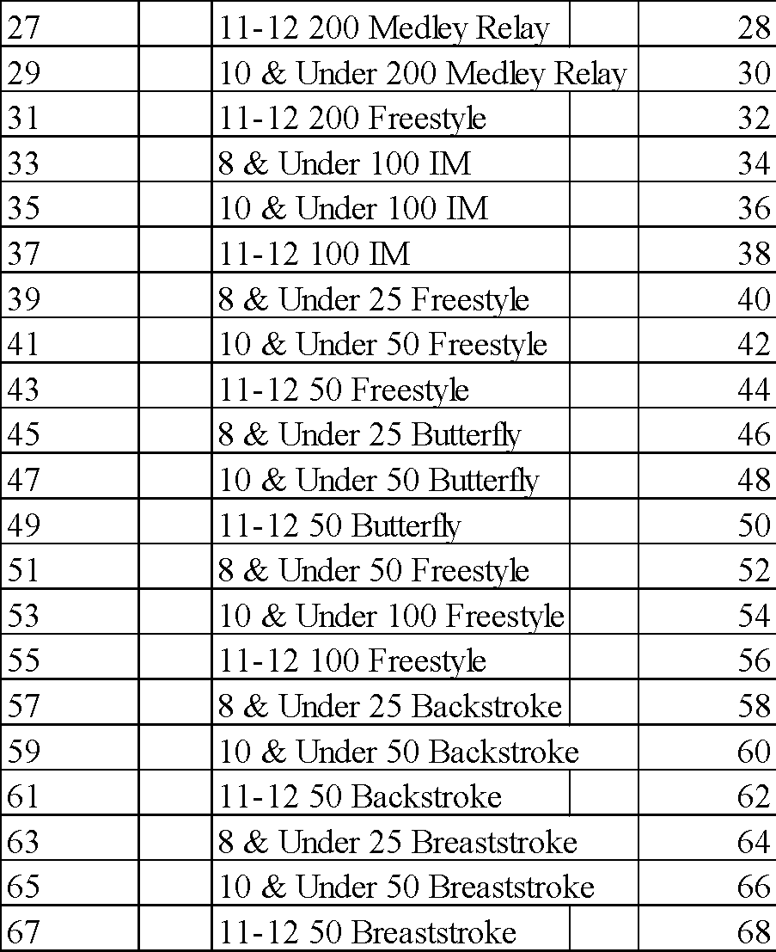
69 10 & under 200 Free Relay 70
71 11-12 200 Free Relay 72

RELEASE AND WAIVER
Sanction Number: MI1617028
Enclosed is a total of $__________ covering fees for all the above entries. In consideration of acceptance of this entry I/We hereby, for ourselves, our heirs, administrators, and assigns, waive and release any and all claims against Rockford Riptide, Rockford Public Schools, Michigan Swimming, Inc., and United States Swimming, Inc. for injuries and expenses incurred by Me/Us at or traveling to this swim meet.
>>>>>>>>>>>>>>>>>>>>>>>>>>>>>>>>>>>>>>>>>>>>>>>>>>>>>>>>>
In granting the sanction it is understood and agreed that USA Swimming and Michigan Swimming, Inc. shall be free from any liabilities or claims for damages arising by reason of injuries to anyone during the conduct of this event.
Signature:
Position:
Street Address:
City, State, Zip:
E-mail:
Coach Name:
Coach Phone:
Coach E-Mail:
Club Name:
Club Code: ______________________________________________________________
Certification of Registration Status
Of All Entered Athletes
Fall Fiesta
Sanction Number: MI1617028
Michigan Swimming Clubs must register and pay for the registration of all athletes that are contained in the electronic TM Entry File or any paper entries that are submitted to the Meet Host with the Office of Michigan Swimming prior to submitting the meet entry to the meet host. Clubs from other LSCs must register and pay for the registration of their athletes with their respective LSC Membership Coordinator.
A penalty fee of $100.00 per unregistered athlete will be levied against any Club found to have entered an athlete in a meet without first registering the athlete and paying for that registration with the Office of Michigan Swimming or their respective LSC Membership Coordinator.
Submitting a meet entry without the athlete being registered and that registration paid for beforehand may also subject the Club to appropriate Board of Review sanctions.
The authority for these actions is:
UNITED STATES SWIMMING RULES AND REGULATIONS 302.4 FALSE REGISTRATION – A host LSC may impose a fine of up to $100.00 per event against a member Coach or a member Club submitting a meet entry which indicates a swimmer is registered with USA Swimming when that swimmer or the listed Club is not properly registered. The host LSC will be entitled to any fines imposed.
>>>>>>>>>>>>>>>>>>>>>>>>>>>>>>>>>>>>>>>>>>>>>>>>>>>>>>>>>
I certify that all athletes submitted with this meet entry are currently registered members of USA Swimming and that I am authorized by my Club to make this representation in my listed capacity.
By: ________________________________________
(Signature)
__________________________________________
(Printed Name of person signing above)
Capacity: __________________________________
Club Name: _________________________________
Date: ______________________________________

This form must be signed and returned with the entry or the entry will not be accepted.

Meet Evaluation Form
Sanction Number: MI1617028
Name of Meet: Fall Fiesta Sprint Spectacular
Date of Meet: November 13, 2016
Host of Meet: Rockford Riptide
Place of Meet: Rockford High School Pool
Who do you represent (circle)? Host Club Visiting Club Unattached
Describe yourself (circle) Athlete Coach Official Meet Worker Spectator
Please rate the overall quality of this meet:
(Please write any comments or suggestions below or on the reverse side)
Low High
1. Swimming pool (e.g., water quality, ventilation) 1 2 3 4 5
_______________________________________________________________________________
2. Equipment (e.g., timing system, PA system): 1 2 3 4 5
_______________________________________________________________________________
3. Swimmer facilities (e.g., locker rooms, rest areas): 1 2 3 4 5
_______________________________________________________________________________
4. Spectator facilities (e.g., seating, rest rooms): 1 2 3 4 5
_______________________________________________________________________________
5. Meet services (e.g., concessions, admissions, programs): 1 2 3 4 5
_______________________________________________________________________________
6. Officiating 1 2 3 4 5
_______________________________________________________________________________
7. Awards and award presentations: 1 2 3 4 5
_______________________________________________________________________________
8. Safety provisions: 1 2 3 4 5
_______________________________________________________________________________
9. Overall success of the meet: 1 2 3 4 5
______________________________________________________________________________
10. Other (please specify): 1 2 3 4 5
______________________________________________________________________________
Return this completed evaluation to a representative of the Meet Host. Thank you.
Meet Host: Copy all of these submitted Meet Evaluations to the current Program Operations Vice-Chair (Joe McBratnie) and the Michigan Swimming Office (Dawn Gurley and John Loria) within 30 days.

